**Cheap FOCer 2 Hardware List**

**Heatsink:** 1

Any generic heat sink with a flat surface of at least 60mm x 100mm can be used. Below is the example low-cost heatsink used in the original CFOC2 testing.

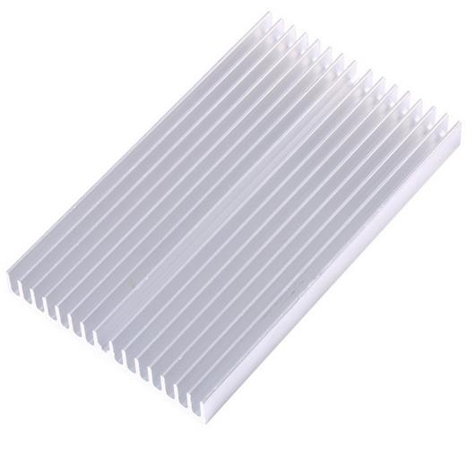

<https://www.aliexpress.com/item/32951112852.html?spm=a2g0s.9042311.0.0.7a894c4dYDsoaK>

**1mm Thermal Pad:** 60mm x 60mm

Thermal pad for thermally coupling the MOSFETs to the heatsink surface. This also electrically insulates the MOSFET tabs from the heatsink (very important). 0.5mm thick thermal pad may not be sufficient to fill the gap between MOSFET tabs and heat sink surface.



<https://www.aliexpress.com/item/32810504639.html?spm=a2g0s.9042311.0.0.7a894c4dYDsoaK>

**M3 x 12mm Hex Socket screws:** 5 per controller

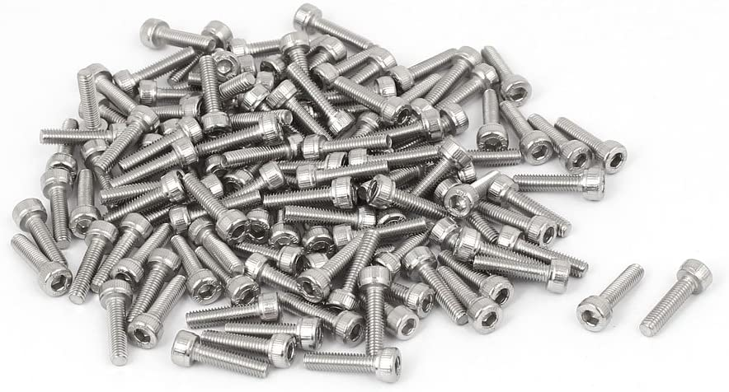

<https://www.aliexpress.com/item/32810872544.html?spm=a2g0o.productlist.0.0.19df1cfe0f2m9D&algo_pvid=769b47e8-4242-4481-b8b9-cfd8b43c02cf&algo_expid=769b47e8-4242-4481-b8b9-cfd8b43c02cf-6&btsid=0ab6f82115870812021408548e17a4&ws_ab_test=searchweb0_0,searchweb201602_,searchweb201603_>

**M3/M4 5mm nylon spacers:** 5 per controller

Spacers to prevent overtightening of screws which cause warping/damage to the PCB.

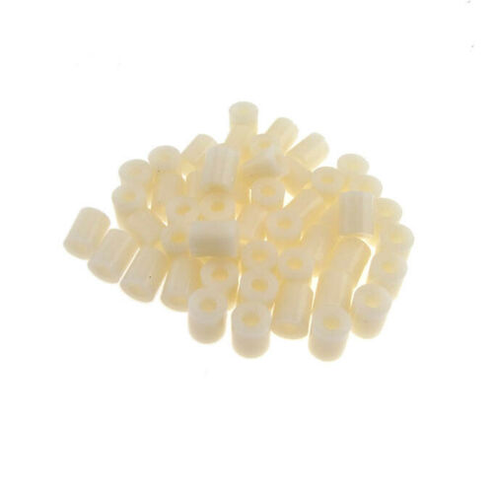

<https://www.ebay.com/itm/OD7-5mm-Nylon-Round-Spacer-Standoff-For-M3-thread-Screw-Blot-QTY50/183743008473?ssPageName=STRK%3AMEBIDX%3AIT&_trksid=p2060353.m2749.l2649>

<https://www.aliexpress.com/item/33047891996.html?spm=a2g0s.9042311.0.0.7a894c4dYDsoaK>

**M3 x 6mm x 1mm nylon washers:** 5 per controller

Washers to be used between screw head and top side of PCB. Prevents rubbing between screw head and PCB surface.

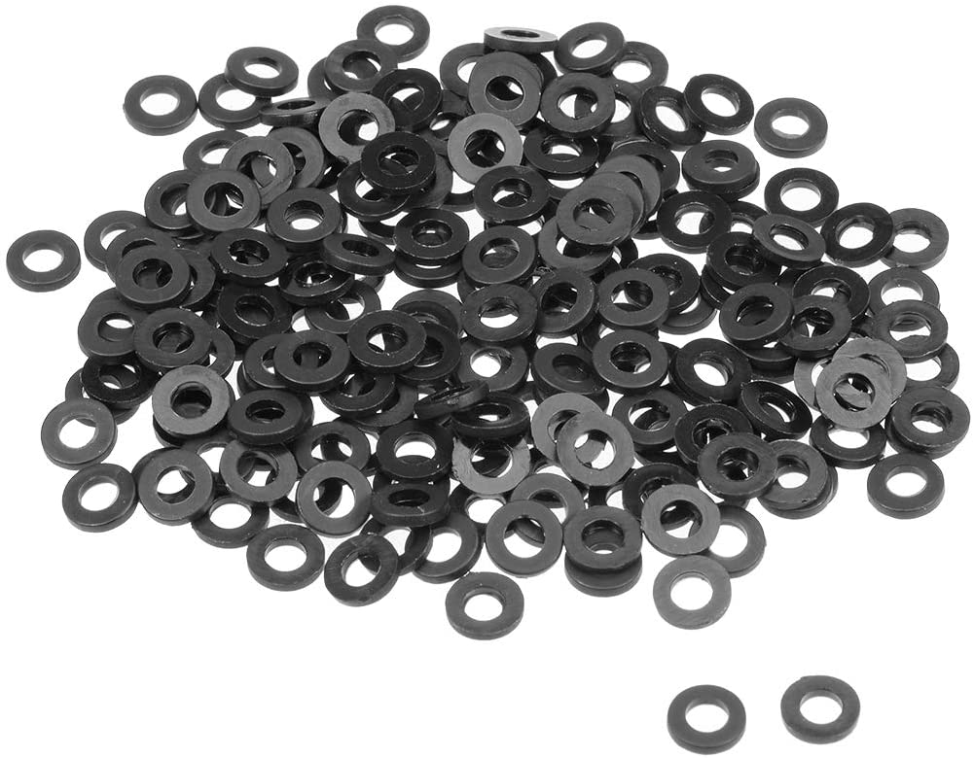

<https://www.aliexpress.com/item/33021883302.html?spm=a2g0o.productlist.0.0.2126290cxVS3M5&algo_pvid=82a621d5-060e-4077-9c64-22d559d691e7&algo_expid=82a621d5-060e-4077-9c64-22d559d691e7-1&btsid=0ab50f4415870809832364456e0a4e&ws_ab_test=searchweb0_0,searchweb201602_,searchweb201603_>

**JST PH 2.0 Pigtails (optional):**

JST male connectors with wires included. Makes for convenient and quick setup of controller with external accessories.

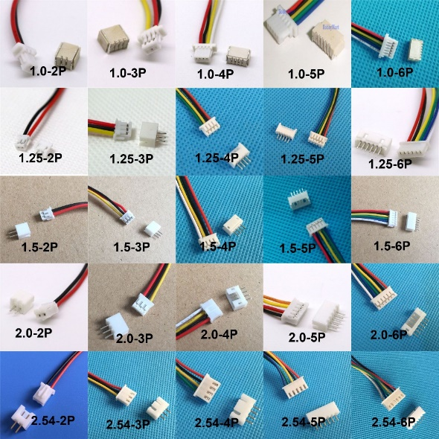

<https://www.aliexpress.com/item/32733307616.html?spm=a2g0s.9042311.0.0.7a894c4dYDsoaK>

**60mm 5v Fan (optional):**

Fan that can screw onto recommended heatsink fins. Provides extra cooling and is recommended if space allows and/or if high currents are used in operation. Powered from 5V supply of controller.

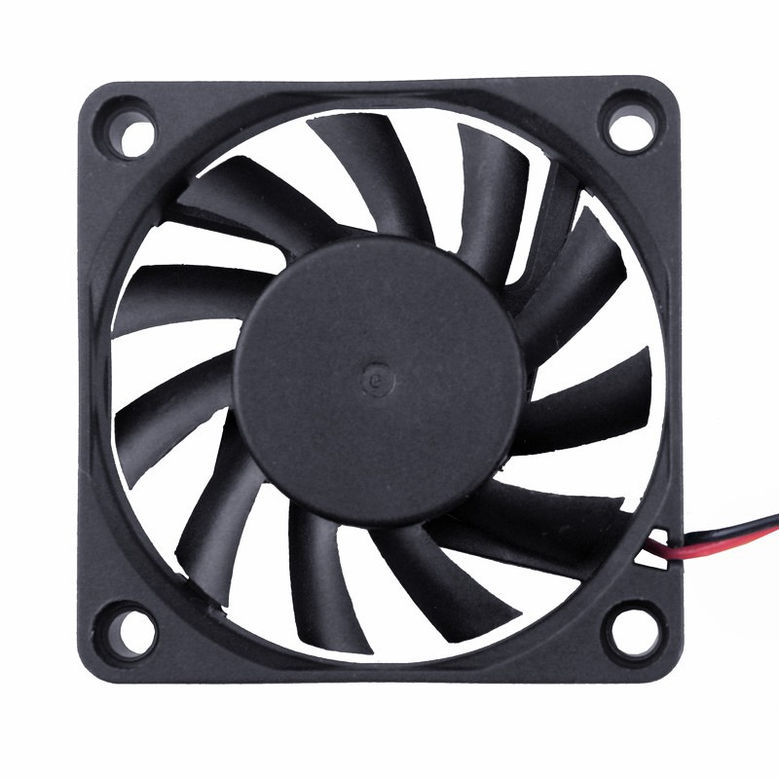

<https://www.aliexpress.com/item/32571979071.html?spm=a2g0s.9042311.0.0.7a894c4dYDsoaK>